Business Cycle:

1. Mainstream business cycle theory: Potential GDP grows at a steady pace while aggregate demand grows at a fluctuating rate, real GDP fluctuating around potential GDP
2. Real business cycle theory: it regards random fluctuations in productivity as the main source of economic fluctuations.

Impulse: the productivity growth rate that results from technological change, a period of rapid productivity brings an expansion, and a decrease in productivity triggers a recession.

Two effects follow from a change in productivity:

1. Investment demand changes: decrease in productivity => decrease in investment demand => decrease in demand for loanable funds

Real interest rate falls => the quantity of loanable funds decrease

1. The demand for labour changes: real interest rate falls => the supply of labour decreases

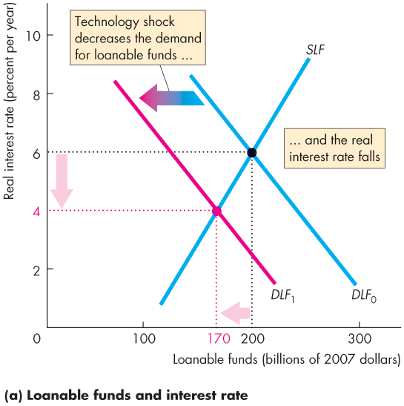Inflation Cycles:

1 Demand pull inflation: an inflation that starts because aggregate demand increase

2 Cost push inflation